Travelwise messages for your newsletters

Here are some road safety messages to copy and paste in your school newsletters throughout the year. Real life photos of your Travelwise campaign can also be used.

You might also like to use the messages as a classroom activity by developing posters, making bookmarks for presents or making post cards to send home.

We are now a Travelwise school! This means we will be working with Auckland Transport on road safety and making trips to school active, social and safe.



Our school is a TravelWise school

We encourage you to walk your children to and from school as it:

* Helps improve your child’s fitness and health (and yours!)
* Gets them to arrive at school awake, alert and ready to learn
* Keeps the school gate area clear of parked cars so it is safer for everyone
* Helps your child to become familiar with their community and to learn road sense skills
* Saves on petrol money

**\_\_% of this school travel by car… that means there is approx. \_\_\_ cars at our gate, twice a day!**

**Can you leave your car at home 1 day each week?**

(fill in with information from Travelwise Surveys)

# Stay Dog Safe

If you see a dog roaming loose on the street or encounter a dangerous dog please report it as soon as possible to allow the Animal Control Officers an opportunity to catch the dog while it is still roaming.



Call the Auckland Council Call Centre on 09 301 0101.  Call anytime 24 hours a day, 7 days a week. They will report it to Animal Management. Please remember to provide as much information on the dog & the location

When walking to school, your child may come across a loose dog – here are some tips you can teach them to stay dog safe.

* Quiet and slow – it’s the way to go!

If you are scared of a dog, move quietly and slowly away from it. Don’t run. It is better to walk away quietly and slowly. Don’t stare at the dog as you move away. If you stare, a dog might think you want to fight.

### Don’t run and shout - it freaks us out!

Do not run around or shout near a dog. Dogs react to the way we behave. If you shout or run a dog might chase or attack you.

And remember, if you own a dog, make sure it is tied up or behind a fence in the morning and afternoon when children will be out walking to and from school.

## STOP, DROP & GO!

This is not a car park, it is a drop-off / pick-up bay, please abide by the rules.

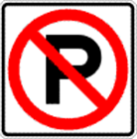

**Safety Belts Save Lives**

Always buckle up, front and back.

Children need to be in an appropriate child restraint for their age and size

[www.**childrestraints**.co.nz](http://www.childrestraints.co.nz)

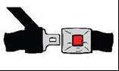

## Back for the Future

Take special care when reversing. Look out for all children. Know what is behind before you go back. 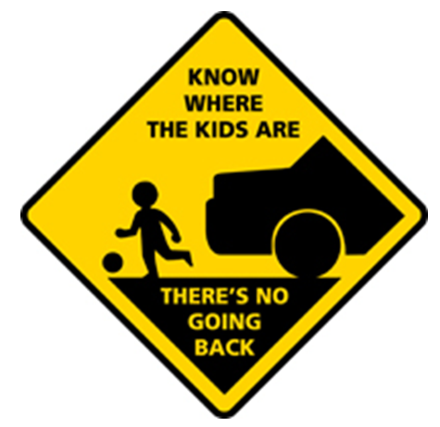

## Keep Safe Getting Out

The safest door opens onto the footpath side. This will keep children away from the busy road.

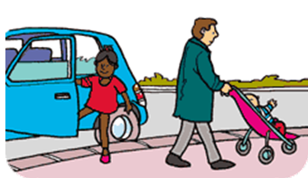

## It is everyone’s responsibility to keep our kids safe

Keep our children safe … and park safe.

Please play your part by:

* Always observing the parking restrictions near the school
* Always using the school patrol crossing
* Choosing safety over convenience at all times
* Walk with your child or join a Walking School Bus

**Stop chaos at the school gate**

Never stop on yellow lines or double-park around the school. Parking like this can block the view of students and motorists making it hard for students to safely cross the road.

Develop your child’s road sense and let them walk the last 500 meters to school.



## Parking

Respect your school community.

**Do not** park on footpaths, driveways, or crossings.

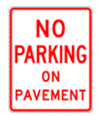

### Quick Tips for escaping school gate chaos

Do you often drive your children to school in the morning or pick them up in the car in the afternoon?

Do you get stuck in traffic on the way?

When you eventually arrive, do you then have problems finding somewhere safe to park?

Try these quick tips to make your life a little less stressful -

* Park a little further from the school and walk with your child the rest of the way
* Walk to school with a group of parents or children from your street
* Find out about our Walking School Bus

BD10290_

**Safety at the school gate**

We encourage you to walk with your children to school, but if you need to drive them sometimes, please observe and discuss with your child the following safe practices:

##### Dropping Off

* Park a short distance from the school and walk with your child/ren to school. (Help keep the school entrances free from cars to make it safer for everyone.)
* Always park beside the footpath and ensure children exit vehicles on the footpath side and not the roadside.
* Always use the pedestrian crossing to cross the road.

#### Picking up

#### Park and walk to the school grounds to meet your child/ren.

* Do not wave or call your child/ren across the road.
* Always educate your child/ren to use the pedestrian crossing.
* Always role model good safety behaviour to your child/ren and teach safe habits.
* Always drive slowly near the school and watch for pedestrians and cyclists at all times.

BD10290_

**What children would like drivers to know:**

We are not little adults, so don’t expect us to act as you do. We are small and often can’t see over parked vehicles. This also means you can’t see us.

Please don’t park on the yellow lines outside our school - you are stopping other drivers from seeing us on the crossing. We can freeze when we find ourselves in danger, instead of taking quick action as you might. Walk with us or join a Walking School Bus with us.

Help to keep us safe around schools.

BD10290_

### Dropping children off at school

Dropping children off as close to the school gate as possible may be convenient for you, but can cost another family a lifetime of pain and suffering. All our children deserve the chance to grow up and experience life to it’s fullest.

Parking restrictions are in place near schools for a reason. They protect our communities’ children.

* Always observe all parking restrictions near our school
* Always use the school patrol crossing
* Choose safety over convenience at all times
* Where possible walk or join a Walking School Bus with your child

BD10290_

**Stopping traffic at the school gate**

Traffic at the school gate is a potential danger. Our school is part of the TravelWise programme and is working towards creating a safe culture for everyone getting to and from school.

For the safety of your child and their friends:

* Always observe all parking and drop of zones restrictions near our school.
* Always use the school patrol crossing.
* Choose safety over convenience at all times.
* Where possible walk or join a Walking School Bus with your child.

BD10290_

j0428345**Sitting duck**

Never call your child across the other side of the road. Excited children often dash out on to the road forgetting to look for traffic. Children cannot accurately judge traffic speed.

## Support the message….Cross at the lights!

Speak with your young people about using the legal crossing.

Dodging in and out of cars to cross is dangerous, let them know why.

**Watch Out For Sneaky Driveways!**

Tall fences and trees can hide cars reversing. So use your eyes and ears to check what is happening.



## Always Use the Crossings

Children will copy your example, good or bad. Always use the safe crossing areas, respecting the road patrollers.

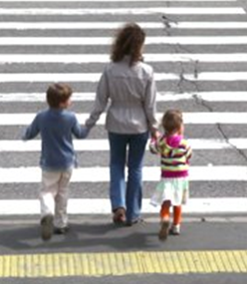

## Our school has a 40km Speed Zone

Please stay within the sign posted speed limit. This is for the safety of your young person and their friends

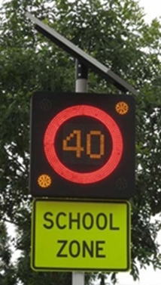

## Our school has a School Zone

Please slow down within this zone and watch for students walking and on wheels.

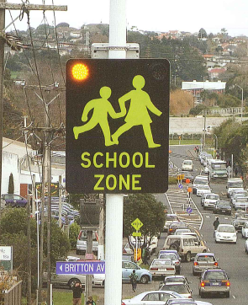

## Avoid the congestion!

Avoid the stress and congestion at the school gate. Park 500m+ away from the school and let your young person walk the short distance to school

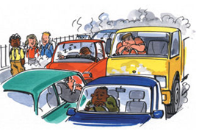

**Independent Travel**

This is a great age to start increasing your young person’s confidence and ability to travel independently.

Check out public transport as an option for your tween.

AT.govt.nz



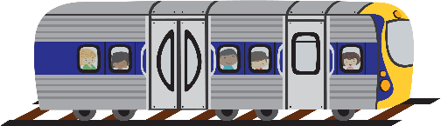

**Make it click, did you know…**

If everyone wore their seatbelts, it is estimated that 25 lives could be saved from road crashes each year. Wearing a safety belt reduces the risk of being killed or seriously injured in a road crash by about 40%.

If a car suddenly stops when traveling at 50km/h the human body is like a pinball bouncing off the inside of the car. An unrestrained body can collide with people in the car who are wearing their safety belts, severely injuring them.

MCj03709240000[1]

**Be prepared on rainy days!**

Wet days mean more traffic and less visibility. Extra care and patience is needed when driving… and parking. Use your lights, bring an umbrella and be prepared to walk to pick up your child. Better to catch a few raindrops than collect a car. Park safe, and keep our children safe.



## Walk with friends.

Walking together is fun and improves your personal safety.

Choose a meeting spot and make sure you check in if you mate is late!



## W A L K !

It’s good for:

* Your health
* The environment
* Your pocket
* Your social life



## Set a good example… walk to school!

Why not walk to and from school with your child? It’s the perfect opportunity to teach your child road safety skills and it’s good for family fitness.

**Walking is Fun, Free, and Fast!**

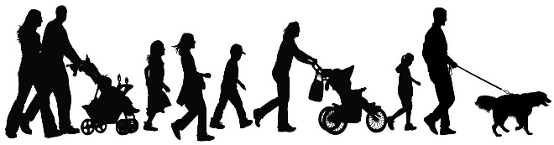

**Be prepared on rainy days!**

On wet days, why not

swap the car for

raincoat and gumboots!

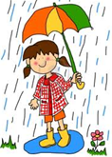

## W A L K !

It’s good for:

* Your social life
* Fitness
* The environment
* Your pocket



**Establish Good Habits**

Walking is a learned behaviour. If children are driven everywhere they will expect to be driven. The more you walk, the more likely you are to walk – to the shops, to a friend’s house, to the beach. People who get into good exercise habits in childhood are more likely to grow into healthy adults.

**Petrol saving**

Short trips use more fuel and emit more harmful chemicals, such as carbon monoxide. They also cause more wear to brakes, tyres and engines, leaving

behind oil, grease, rubber, metals and hydraulic fluid on the road to wash into rivers and the sea. With Petrol costs at a high try reducing trips, carpool with others, drop and walk

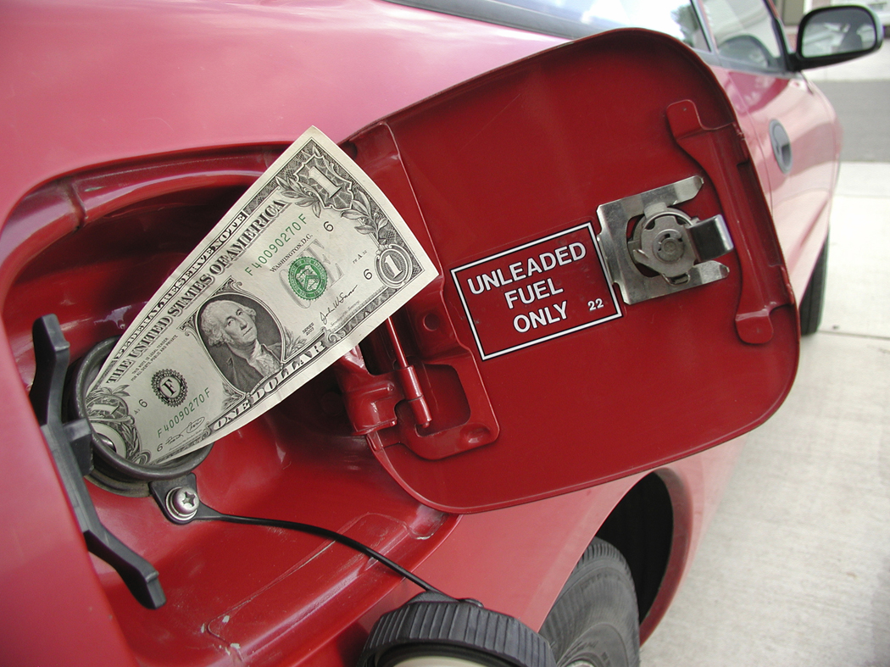

**Lets get our kids active**

Nearly a third of New Zealand children get very little or no exercise every week. Childhood obesity levels are rising, and with them health problems, such as high blood pressure and joint problems

. bd10675_

Walking is a moderate exercise, which means anyone can do it. It is good for the heart, blood pressure and lungs, and burns calories. It is also a weight-bearing exercise, which means it builds stronger bones.

.

**Keep the car on the road**

Children don’t expect to see cars on their footpath. Don’t park across the footpath and if you have to turn into a driveway, use extreme care.

j0437683

**Did you know**…

That about 40% of our carbon dioxide emissions come from transport, mainly private cars?

There are huge opportunities for us to reduce our ‘carbon footprint’ by making a few simple changes.

* Keep your tyres inflated, you’ll use less fuel.
* Car pool or walk to school– you’ll cut down on petrol and wear and tear on your vehicle, as well as reducing congestion and pollution.

For further information, go to [www.chokethesmoke.govt.nz](http://www.chokethesmoke.govt.nz)

**10 great reasons to walk to school with your children!**

Walking to school is an excellent way to include daily physical activity into your child’s life. And if you walk with them, it’s an excellent way to get some physical activity for yourself too.

Here are 10 great reasons to walk to school together:

1. It’s fun
2. It’s healthy
3. It’s non-polluting
4. It’s friendly
5. It reduces stress
6. It’s a chance to teach and learn road safety skills
7. It’s considerate
8. It’s educational
9. It’s free – no petrol money
10. It makes the street outside the school safer

BD10290_

**A big thank you to all those families whose children walk to school**

By encouraging your children to walk to school, you are:

* Protecting the environment
* Reducing traffic congestion in our community
* Improving the safety of our neighbourhood

You are also providing your children with important opportunities to:

* Participate in regular physical activity
* Learn road-sense skills
* Develop independence
* Get to know their community
* Improve their social skills

You are making a big difference for your children, your community and your planet

Thank You!

BD10290_

## Set a good example… walk to school!

Why not walk to and from school with your child? It’s the perfect opportunity to demonstrate safe behaviour and it’s good for your fitness and the environment. One less car at the gate means it’s safer for other children too.

BD10290_

**Did you know that….**

In an Auckland study, parents reported increased levels of communication with their children since starting to walk with them to school. Free from the distractions of driving, the walk can present a perfect opportunity to ask children about their day and to observe and discuss things that are in the neighbourhood such as birds, trees, telephone poles or the rubbish truck.

Many parents also reported that through walking to school they have met their neighbours and been able to teach their children safe houses they can go for help. This gives children a stronger sense of community and provides them with an opportunity to develop social skills and to interact with different people. Walking to school also provides children with an opportunity to develop independence and can build self-confidence.

Walking to and from school can set children up for the day and give them an opportunity to wind down at the end of the day. Parents in the study reported improvements in the mood and the behaviour of their children through walking to and from school.

BD10290_

### Walk to school to keep active

Free, convenient, enjoyable and does not require special equipment or training: Walking to school is a great way for adults and kids to be active. Lack of physical activity is a major cause of chronic illness including heart disease, diabetes, some cancers and osteoporosis. Being overweight can cause health problems like diabetes during childhood and research shows that physically inactive kids are more likely to grow up to be physically inactive adults – and are therefore at high risk for a number of illnesses.

There are plenty of great reasons to walk to school – less traffic, safer streets, cleaner air – but one of the best is that children and parents will be healthier. With increasing levels of obesity and many children not getting the recommended daily dose of physical activity (just 30 minutes), it's an ideal time to start walking to school for your child’s health and well-being.

BD10290_

**Did you know that……**

Many New Zealand children do not participate in enough physical activity to protect their health. Regular physical activity can lead to the prevention of obesity and chronic diseases such as heart disease, diabetes, some cancers and osteoporosis. Walking to school is an excellent way to incorporate regular activity into your children’s daily schedule.

BD10290_

**Walk to School! Save the planet**

Cars produce more pollution (per kilometre) on short journeys, when the engine is cold and the car keeps stopping and starting in traffic jams – does that sound like your journey to school? The morning “school run” is one of the most polluting journeys you can make. The list of pollutants thrown out by car exhausts is not pleasant reading. It includes:

* Carbon monoxide – a poisonous odourless gas
* Carbon dioxide – which is a major cause of global warming
* Benzene – which can cause cancer
* Particulate matter – minute specks of soot (a tenth of the width of a human hair) which can enter the lungs and make breathing harder

More worryingly, research has shown that the levels of pollutants inside a car are at least 3 times worse than on the footpath at the side of the road – so driving to school isn’t just bad for the environment, it is bad for your health!

Walking to school is a great way to “do your bit”, in the same way as recycling your bottles and turning off lights. We want to encourage everyone to consider how they travel to school, and try walking to school for a week. Who knows, you might just find it is quicker, healthier and less stressful!

**Do you live close to off road cycleways?**

This could be a great way for students to travel to school safely. Find and order maps here…

AT.govt.nz

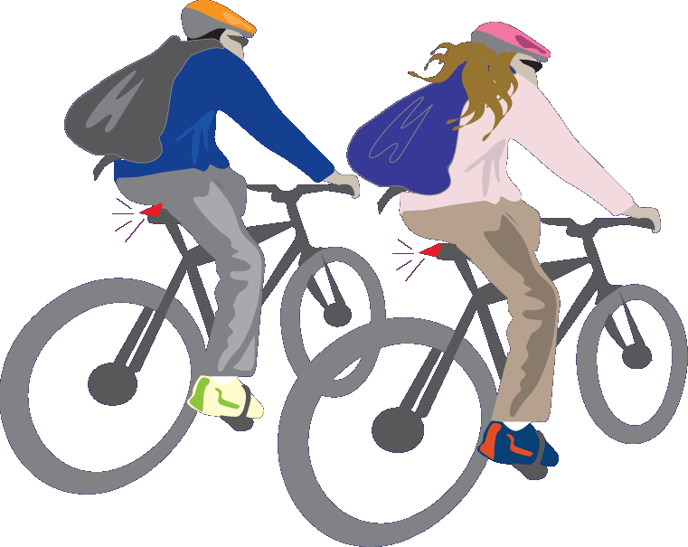

**Share with Care**

Footpaths are for everyone, older people, prams, kids and scooters.

Be part of your community, share the space.



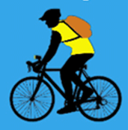



**Be safe be seen**



**A good helmet should…**

* Always be worn
* Fit snuggly, with tight straps
* Be NZ standards approved

[www.nzta.govt.nz](http://www.nzta.govt.nz) (under cycling)

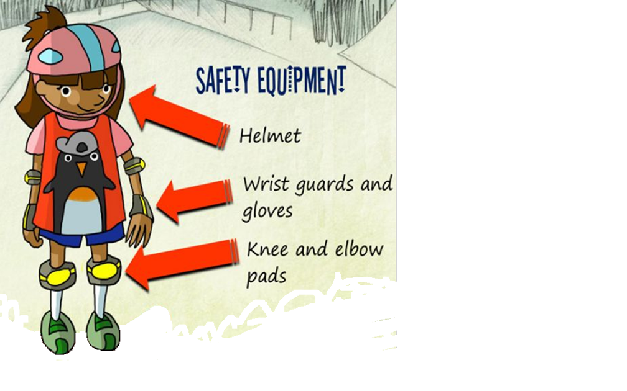

Recommended safety gear for scooting and skating.

###### **Profile Families who regularly walk to school**

Each week, select a family who regularly walks to school and profile them in the school newsletter. As well as printing details about how many children in the family walk and what direction they come from, you could ask them questions such as how long they’ve been walking to school, what they enjoy about walking to school, how it benefits the parents, what the children enjoy etc. You could also include a photo.

BD10290_

**Remembering when we walked to school**

The number of children being driven to school has doubled in the past 20 years. Many adults have fond memories of the ‘adventures’ they had walking to school, something many of today’s children are missing out on. Ask the principal, some teachers, and some parents to recount the memories they have of walking to school. Publish the stories in the school newsletter to jog parents’ memories of their own experiences, and urge them to allow their children to experience the joys of walking to school, just like they did. You could even run a parent competition for the best story submitted.

BD10290_

# Children’s stories

Interview a group of children about what they experience on the way to school and write a magazine style article from it. Alternatively, a group of senior students could conduct the interviews and write the story. Another idea is to ask children to write a poem or story about their journey to school, and the best ones could be included in the newsletter.

BD10290_